**Instructions**:

Complete the tasks below and bring your homework to the next class.

Task 1:

You should spend about 20 minutes on this task. Write a report for a university lecturer describing the information in the graph below. You should write at least 150 words.

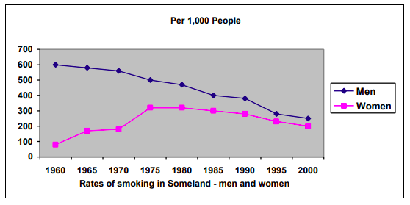

The line chart shows the men’s and wamen’s rates of smoking in Someland from 1960 to 2000. Whilst women’s rates of smoking decreased slightly after its increase, the men smokers witnessed a fairly steady decrease throughout the about forty years.

Both men and women have experienced the continuous decrease of smoking rates since 1975. However, between 1960 and 1975, the women’s smoking rate has increaseed sharply from less than 100 and peaked at 300 in 1975 which is 3 times as its value in 1960. However, the men’s rates of smoking has kept steadily decrease since 1960. It is expected that both men’s and women’s rates of smoking will keep on decreasing in the future decades.

In conclusion, the charts highlight the difference between changing of men’s and women’s rates of smoking in the middle of the 20th century, but steady decreasing in the past few decades.